Information Technology
Labor Market Information and Analysis
The following labor market information profiles the Information Technology occupation and related Computer Analyst occupation in San Diego and Imperial counties.

- Computer Systems Analysts (SOC 15-1121): Analyze science, engineering, business, and other data processing problems to implement and improve computer systems. Analyze user requirements, procedures, and problems to automate or improve existing systems and review computer system capabilities, workflow, and scheduling limitations. May analyze or recommend commercially available software.

In 2016, there were 5,735 computer systems analyst jobs in San Diego & Imperial counties that typically require a Bachelor’s degree (Table 1). Looking forward to 2021, the labor market demand for computer systems analysts in the region is projected to grow by 11% (growth of 610 jobs). There will be 2.483 open positions due to retirements or other replacement factors in the next five years.

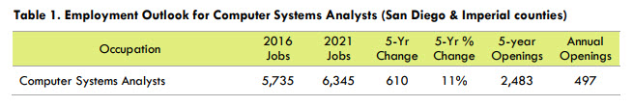
The median hourly wages for computer systems analysts is $43.43 in San Diego and Imperial counties. A more in-depth wage breakdown can be found in Table 2.

Job Postings
To identify job postings related to computer systems analysts, the SOC code listed in above was used. In the past 12 months (Sep 2016-Aug 2017) there were 2,216 job postings related to computer system analysts, indicating high demand for this single occupation. The most common job title in the employer job postings was systems analyst (392 job postings).
